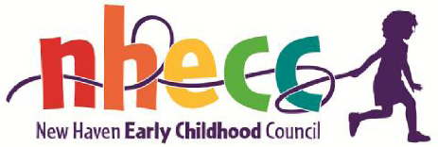
Proposal from the NHECC School Readiness Committee
Proposal for Discussion and Vote

PART 1
Motion: The New Haven Early Childhood Council vote to approve the recommendations of the School Readiness Committee which would remove 50% of unfilled spaces in 6 SR programs and 100% of spaces offered by NHPS, move them to 8 SR programs in order to add 10 prek spaces and 17 infant/toddlers spaces thereby increasing utilization.
Background:
The School Readiness Committee met on December 12 and discussed 4 options for moving unfilled spaces to SR programs that can fill the spaces. The data used to make this decision was a survey of all the SR programs. The survey asked how many unfilled SR spaces the program had as of Dec 1, how many spaces would be filled by January 2024 and how many spaces a program could fill by March 1. Filling spaces included prek and infant/toddler seats. Programs could also request converting current SR spaces to either a prek or infant/toddler space.

The committee recognized that by moving and filling underutilized spaces, the Council has a better chance of meeting the OEC’s requirement to fill 95% of all SR spaces and thereby get back from OEC the 57 spaces lost last year due to underutilization.

Committee reviewed and discussed the spreadsheet which outlined 4 options and selected the option as described in the Motion above.

It is important for the Council to understand the programs with remaining unfilled spaces will be helped by the Councils recruitment efforts of parent incentives to fill spaces in the programs where their children are enrolled as well as the lawn signs advertising openings that will blanket the underserved neighborhoods come January 2024.

PART 2

Motion: Given the uncertainty of getting spaces back from OEC in January, or how many we may receive, the request is for the Council to vote today to award any funds OEC return to the 3 infant/toddler programs that requested more spaces than they received in the Part One Motion. The awards of additional spaces will be made based on prioritizing spaces to programs with currently enrolled New Haven infant/toddlers. The 2nd priority would be programs with a waitlist for New Haven infant toddler spaces to receive the balance of funds.

