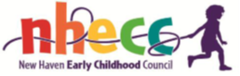

Meeting Agenda
October 4, 2023
Time: 4:00 - 5:30 pm
United Way of Greater New Haven

- Welcome & Call to Order

- Announcements

- School Readiness

  - Restoration of SR spaces
    - OEC process (Att. 1) Discuss
    - Enrollment to date (Att. 2) Discuss
    - Strategies to increase enrollment (Att. 3) Action
  - Policy on non-resident children (Att. 4) Action
  - Program requests for additional SR spaces Action
  - Update on School Readiness Liaison position Discuss

- Update on Connecticut Blue Ribbon Panel on Child Care

- Other Council Business

- Adjourn

