All New Haven children, birth through 8 are healthy, safe, thriving in
nurturing families and prepared to be successful lifelong learners.

NHECC Council Meeting Minutes
September 6, 2017
Time: 1:00-3:00 pm
United Way of Greater New Haven

July Council Meeting Minutes

The July Council meeting minutes were unanimously approved.

Co-Chair Report

Dr. Kimber shared that he is visiting various school readiness sites in New Haven. Dr. Kimber has visited Friends Center and Yale New Haven Hospital Day Care to date. He will work with Randi to schedule at least two or three per month. His goal is to visit all sites that the Council supports through the SR Grant.

Dr. Kimber also shared that Dr. Mayo has agreed to allocate $45,000 to the Council to support a common application pilot. Dr. Kimber has charged the proposed Personnel Committee with reviewing the proposal and other projects to establish a hiring procedure for the position should it be approved.

Operations Committee Retreat Report
Dr. Maysa Akbar provided an overview of the work done at the August NHECC Operations Committee Retreat. Dr. Akbar highlighted the following:

Key Challenges:

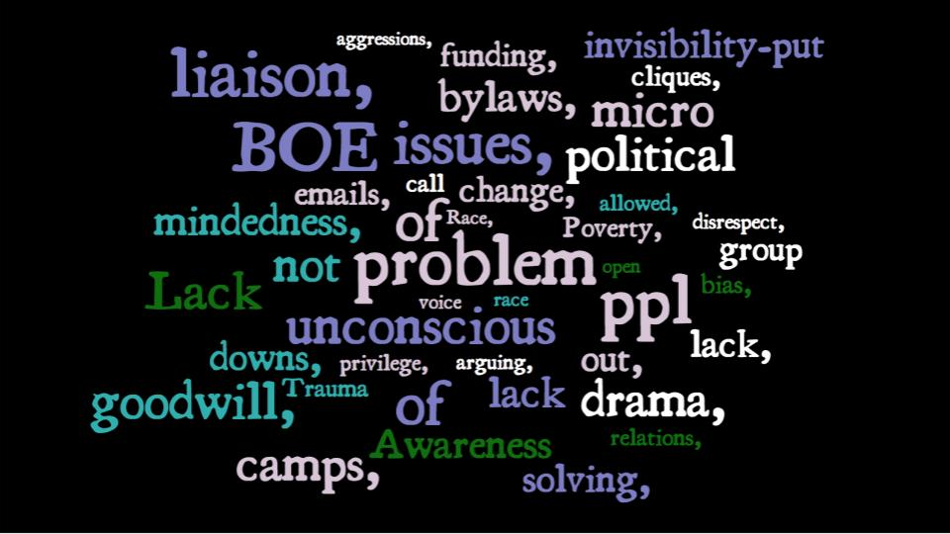

Action Steps:
Retreat attendees proposed a new committee structure for the Council which was reviewed during the meeting. Council members agreed to review the recommendations and bring questions to the October Council meeting.

Proposed Committee Structure

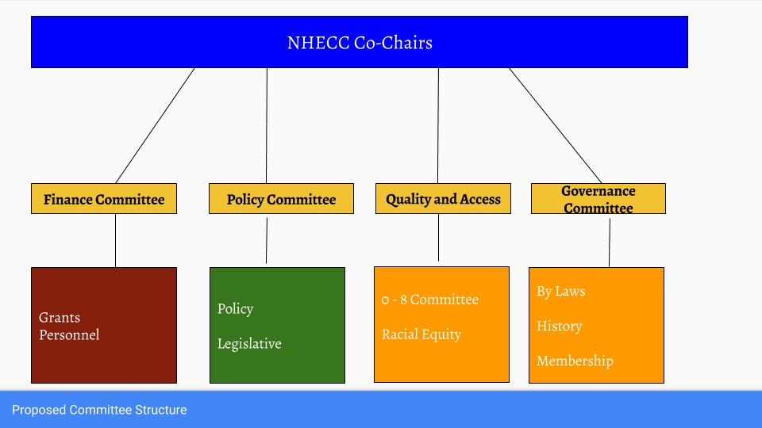

School Readiness Program Director’s Report

Denise distributed a report showing the SR funds spent and enrollment in programs by race and ethnicity. For copies of the report, please email denise.duclos@nhps.net.

Announcements

Susan Logston retired from Gateway Community College. The Council presented her with a gift of appreciation. She will continue to support the Council’s work along with a new designee from Gateway Early Childhood Learning Center.

Meeting Time Change

The Council considered and approved the change of time for the monthly Council Meetings. For the months of October, November and December, the Council will meet at 1:00 PM instead of 3:00 PM.

